Sexton

John S Butler

## GENERATE DATA

summary(Data)

## Conversion Age Distance Angle Location   
## Min. :0.00 Min. :20.05 Min. :10.07 Min. :-44.5065 Away:48   
## 1st Qu.:0.00 1st Qu.:22.18 1st Qu.:24.39 1st Qu.: -7.1199 Home:52   
## Median :1.00 Median :25.11 Median :37.18 Median : 0.7245   
## Mean :0.61 Mean :26.05 Mean :36.35 Mean : -1.1825   
## 3rd Qu.:1.00 3rd Qu.:30.11 3rd Qu.:50.55 3rd Qu.: 8.9305   
## Max. :1.00 Max. :32.93 Max. :59.20 Max. : 22.5811

Sexton = glm(Conversion ~ Distance, data = Data,family=binomial("logit"))   
summary(Sexton)

##   
## Call:  
## glm(formula = Conversion ~ Distance, family = binomial("logit"),   
## data = Data)  
##   
## Deviance Residuals:   
## Min 1Q Median 3Q Max   
## -2.21737 -0.03119 0.00030 0.01127 1.35217   
##   
## Coefficients:  
## Estimate Std. Error z value Pr(>|z|)   
## (Intercept) 28.6540 9.5742 2.993 0.00276 **  
## Distance -0.6798 0.2294 -2.963 0.00305 **  
## ---  
## Signif. codes: 0 '***' 0.001 '**' 0.01 '*' 0.05 '.' 0.1 ' ' 1  
##   
## (Dispersion parameter for binomial family taken to be 1)  
##   
## Null deviance: 133.750 on 99 degrees of freedom  
## Residual deviance: 18.256 on 98 degrees of freedom  
## AIC: 22.256  
##   
## Number of Fisher Scoring iterations: 9

library(ggplot2)  
ggplot(Data, aes(x=Distance, y=Conversion)) + geom_point() +   
 stat_smooth(method="glm", method.args=list(family="binomial"), se=FALSE)+xlab("Distance (m)")+ylab("Pr(Conversion)")+ theme(plot.title = element_text(hjust=1.0))+geom_vline(xintercept=50,col="black",size=1,linetype="dotted")+ geom_text(aes(x=53, label="Half Way Line", y=0.5),angle=90)+  
 geom_vline(xintercept=0,col="black",size=1,linetype="dotted")+ geom_text(aes(x=3, label="Goal Line", y=0.5),angle=90)

## `geom_smooth()` using formula 'y ~ x'

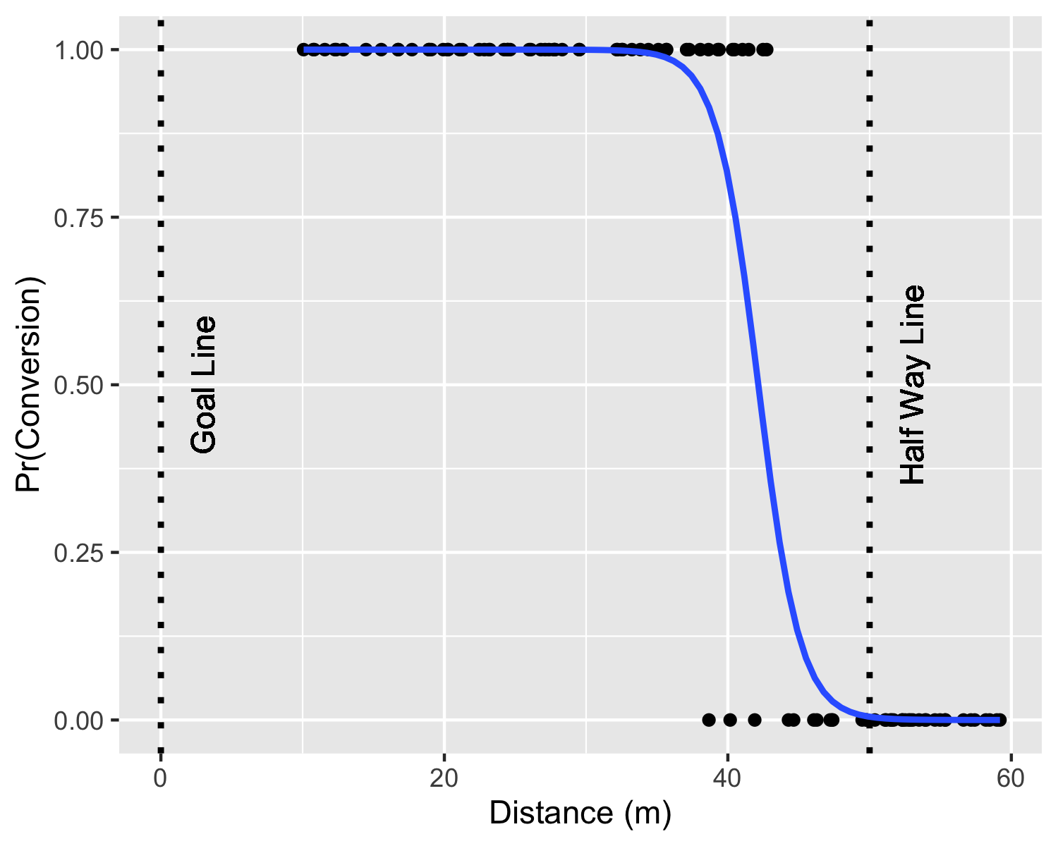

# ggsave("Sexton.png",dpi=300, width = 4, height = 2.5)